**CATS Time Tracker User Guide**

Contents

About Tool 1

Initialization and Adding Chargelines 1

Adding Chargelines 1

Recording Time 2

Exporting Time to SAP 3

Checking for SAP Scripting Access 3

# About Tool

The CATS Time Tracker is a desktop application developed with Python and Tkinter, designed track activities and time spent efficiently. This tool offers a user-friendly interface to log activities, monitor time investment, and manage tasks with ease.

# Initialization and Adding Chargelines

Upon first launch, the application will create a folder structure in your documents directory (\Documents\SAP Time Tracker). This includes:

* **Time Records Folder:** Stores daily time tracking records in the format time_charge_MM_DD_YY.
* **Chargeline File:** Contains all chargelines for timekeeping.

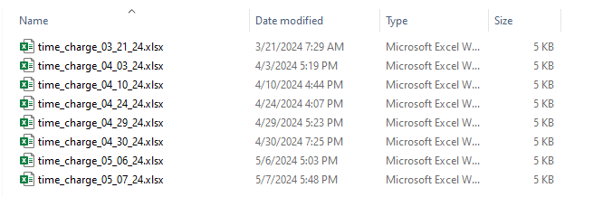

## Adding Chargelines

1. Navigate to File and select "View/Modify Chargelines".

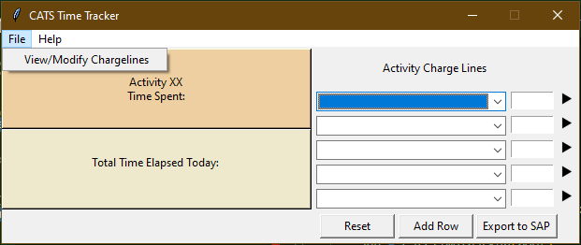

1. If no chargelines are saved, select "Add Chargeline".
2. Enter a description/title and fill in the necessary fields (Network, Operation, Sub-O values).
3. Click the Save icon to store changes.



1. After adding all chargelines, click "Save & Exit" to close the dialog box. Hit "Reset" on the main window to register the changes.

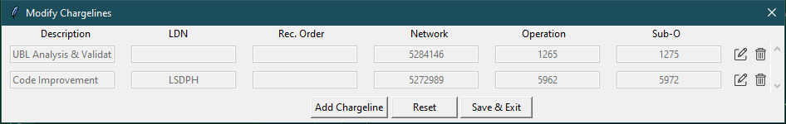

# Recording Time

After setup and adding chargelines, follow these steps to record time:

* **Select an Activity:** Use the dropdown menu to choose an activity based on the added chargelines.
* **Start the Timer:** Click the play icon to start recording time on the selected activity.
* **Monitor Time:** The left display shows total time on the current activity and cumulative time for all activities.

**Switching Activities:**

* **Stop Current Activity:** Ensure you stop the timer before changing activities for accurate recording.
* **Record a New Activity:** After stopping the timer, select a new activity from the dropdown and start the timer.

# Exporting Time to SAP

Follow these steps to ensure accurate data transfer to SAP:

* **Stop Active Time Tracking:** Ensure all timers are stopped before exporting to finalize all time data.
* **Verify Activity Data:** Check the Excel file for correct activity and chargeline associations.
* **Export to SAP:** Click "Export to SAP" to transfer time tracking data to SAP.
* **Store the Record:** Save a record of the transferred data in the Time Records folder for reference.

# Checking for SAP Scripting Access

If you encounter issues while attempting to export your time tracking data to SAP, the problem may be due to a lack of scripting access. Follow these steps to confirm and request the necessary access:

* Confirm Scripting Access:
  + Navigate to the help menu within the CATS Time Tracker application.
  + Open the embedded document titled "Scripting Access Guide."
  + Review the slides to understand how to check if you have the appropriate scripting access in SAP.
* Requesting Scripting Access:
  + If you determine that you do not have scripting access, the PowerPoint will provide detailed instructions on how to request this access.
  + Follow the guidelines to submit a request to your IT support team.